SCS Static Management Program (SMP)
  - Software Installation Guide
Contents
SCS SMP System Requirements 2
System Requirements 2
Operating System 2
Hardware 2
Network 3
Software 4
SCS SMP Server Installation 5
Program and Data Location 7
SMP Server Monitor 7
Software Upgrade 10
SMP Server Maintenance and Troubleshooting 11
Log Files 11
Database 12
SCS SMP Client Applications Installation 15
Program and Data Location 15
Software Upgrade 16

SCS Static Management Program (SMP) System Requirements
The SCS Static Management Program is a client/server system designed to operate within Intranet or VPN network configurations (although it is possible to use it across public networks). The standard SMP configuration consists of one “Server” computer that is accessible from one or more “Client” computers.
The SMP Server has a central role:
- runs the SCS SMP Server service
- holds the central data store
- discovers sensors and scans the sensor data
- provides full SMP functionality to the Client Applications
Client computers host the Client Applications. Typically, a client computer will have the SCS SMP Client and, optionally, the SCS Server Admin and/or the SCS Plan Editor. The server computer may also contain Client Applications, but it is not mandatory. If necessary, it is possible to perform all administration tasks from client machines.
SCS SMP runs on Microsoft OS and uses the Microsoft .NET 4 software platform and technologies.

System Requirements

Operating System
The SCS Static Management Program will run on any Microsoft Windows version which supports Microsoft .NET 4.0 Framework and SQL Server Compact 4.0. SMP has been tested on Windows XP, Windows Server 2003, Windows 7, Windows Server 2008, Windows 8 and Windows 10.

Hardware
SMP has very low hardware demands. Any standard hardware configuration with network connectivity is satisfactory. SMP Server has been tested on low-end laptops with Windows XP and it exhibited little or no performance degredation.
It is recommended to use a desktop computer with two network cards as the server for the best performance and communication with the Client Network. It is recommended that the server computer has a minimum of 2GB of RAM and at least a 1GHz multi core processor. SMP uses multithreading and parallel processing if available.
SMP scans all connected sensors at one second intervals. Since sensors provide multiple values and statuses, this can add up to a significant amount of data. Even though SMP uses custom data compression, estimated history data size for medium size systems (up to 100 sensors) is around 1GB per month. The server computer should have enough disk space to hold this data. The recommended configuration is a 400 GB or larger hard disk.
There are no special hardware demands on client computers. All client applications will run on any existing Windows machine that supports the Microsoft .NET 4.0 Framework and has a network connection.

Network
The SCS Static Management Program (SMP) Server relies on the network for:
- sensor discovery
- sensor data acquisition
- communication with clients
All sensors have to be connected to local network (LAN/WLAN) and the following ports have to be available (opened on system Firewall):
- 30718 (device detection)
- 10002 (data acquisition)
TIP
The SCS SMP Server detects all of the sensors connected to the network automatically. It is possible to check the connected sensors in the Connections window (SCS SMP Admin or SCS SMP Server Monitor). If a device is connected and operational, but was not discovered by the server (not showing in Connections window), it is likely that a network issue is the cause.
The SMP client applications interface with the server using a fast binary network protocol (TCP). For client/server communication the following port must be available for binary TCP (opened on system Firewall):
- 12001 (SMP services)
Note that ports 30718 and 10002 are used on the local network (LAN) where sensors are connected. On the other hand port 12001 is used by client applications usually on the wider network (VPN). It is enough to allow ports 30718 and 10002 through the firewall only locally – client applications don’t use them.

Insight
The SCS Static Management Program (SMP) uses binary TCP (on port 12001) for client/server communication. If the computer hosting the SMP server is available on public Internet and if port 12001 is opened on the firewall then it would be accessible from any computer connected to the Internet.
Although this setup would enable SMP client access from anywhere, it is not recommended due to the security risks involved.
SCS SMP can also expose client services over HTTP/HTTPS protocol using either binary or text format. This is the recommended solution for worldwide access to SMP. Exposing SMP services over HTTP requires additional components (Microsoft IIS, SMP Service Web API) and setup steps.
Since this is an advanced and not commonly used feature, please contact SCS for further information.

Software
Software prerequisites on the server computer are:
- Microsoft .NET Framework 4 (available from Microsoft)
- Microsoft SQL Server Compact 4 (available from Microsoft)
Software prerequisites on client computers are:
- Microsoft .NET Framework 4 (available from Microsoft)
The SCS SMP installation checks for those components and installs them if not present. Although direct installation is not required in normal circumstances it is sometimes advisable to install those components independently prior to SMP installation.
Insight
The standard database option for SCS SMP is the free Microsoft SQL Compact database. SMP uses a custom technique to overcome the data size limit (4GB).

SCS Static Management Program (SMP) Server Installation
The SCS Static Management Program installation files are available from the SCS web site for authorized users. To access SCS Static Management Program Server installation files please follow
this link.
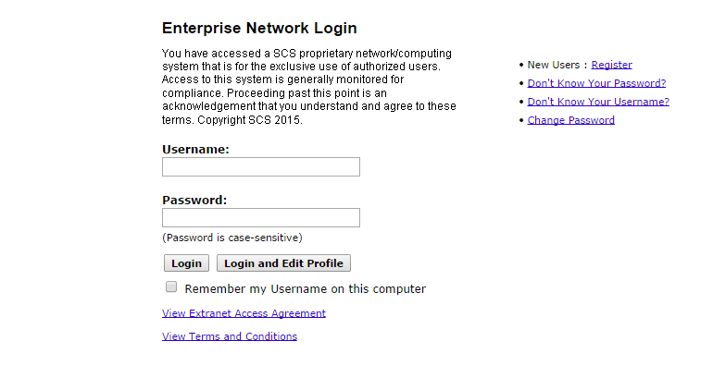
TIP
Please contact SCS representative for credentials required for accessing download site.

Start the installation executable once you obtain it from the SCS site:
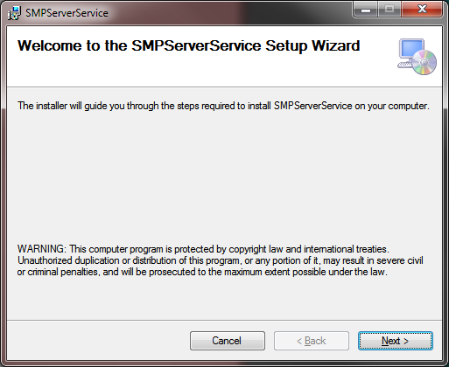
The setup for the SCS Static Monitoring Software is simple, quick, and straight forward. It will install a new system service named SCS SMP Service and start it automatically. Setup also installs a small utility named SCS SMP Server Monitor. Shortcuts are placed in the standard All Programs -> SCS folder as shown below:
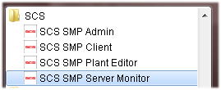
TIP
SMP Server requires Microsoft .NET Framework 4 and Microsoft SQL Server Compact 4 to be installed on the computer. If they are not present, installation will sidestep and install those free components directly from the Microsoft site:
Microsoft .NET Framework 4
Microsoft SQL Server Compact 4
It is also possible to perform this as an independent step before SMP installation.

Program and Data Location
The standard installation creates the folder SCS under Program Files and a subfolder SMPServerService. It is possible to change the program installation location during setup, but this is seldom necessary. The standard program location is (on a typical Windows computer):
- C:\Program Files\SCS\SMPServerService
This folder contains the SCS Static Management Program (SMP) Server and SCS SMP Server Monitor applications. The server runs as a Windows Service.
Data files are located in the folder SCSSMP under common data files. On a typical Windows computer this is:
- C:\ProgramData\SCSSMP
Database files are also located in this folder and they can grow quite large with time. System disk on server computer should have enough free space to cope with this.

SMP Server Monitor
SCS SMP Server runs as service i.e. as part of operating system. It is started at system boot and runs all the time. Windows services have no user interface and therefore we have the SMP Server Monitor application.
This small utility runs silently and it is indicated by small SCS icon in the system tray. When the mouse cursor hovers over it, information about the server version is displayed:
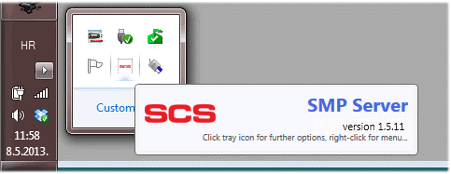
Clicking on the icon brings up a small form:
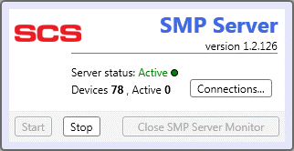

One important server feature is automatic device discovery. Once a SCS static control device becomes connected to a network serviced by the SCS Static Management Program (SMP) Server, it should become instantly “visible” to the server. The server creates a database entity for each new device, and automatically self-starts data acquisition. Discovered devices are identified by their unique serial numbers.
The example on the previous page shows that server has software version 1.2.126, it is Active (running) and there are no active devices in the system.
Let’s assume for the sake of this walkthrough that we have four SCS WS Aware TNG ESD Event Monitors (four grounds) that are active and connected to the network. SMP Server Monitor reveals:
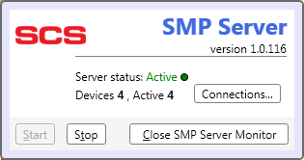
Apart from showing basic information about the server (version, device status) SMP Server Monitor can manage the SMP Server (service). It is possible to start or stop the windows service using the appropriately labeled buttons.
Insight
There is also a button for closing the SMP Server Monitor, but it is disabled while the SMP Server is active. Even though starting the monitor again, if closed by mistake, is an easy task the SCS SMP system doesn’t allow this.
If, for some reason, you want to close this control applet you have to stop the SMP Server first.
Note that there should never be any reason to do that.

Clicking on Connections reveals further network information:
The four devices in our example are connected to a hub (Lantronix device) at the IP address shown. Each device is shown with its serial number and slot id (Modbus ID). This information may be useful to diagnose network connectivity problems.
Insight
SCS Static Management Program (SMP) Server stores all information about the system in a central database. This database is only limited in size by the available disk space, using the free SQL Server Compact for that purpose. The database will contain all data from the moment of first installation. One side effect of this feature is that it is not possible to delete devices. If a device was attached at any time, the server will discover it and store in the database (together with all measurements received from it). If the device is later disconnected, it will remain in database but will no longer be “active”. In this case the Server Monitor will display the devices like this:
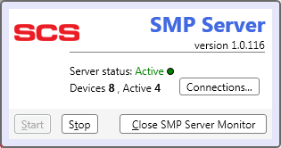
This indicates there are 8 devices in the system database, but only 4 are active at the moment.

Software Upgrade
Whenever a new major software version becomes available, SCS will advertise it and it will be possible to upgrade a running SMP Server to the latest version. SCS Static Management Program (SMP) uses automated software upgrade notifications. Whenever new version is available, the SCS SMP Server Monitor info window will show that a new version is available:
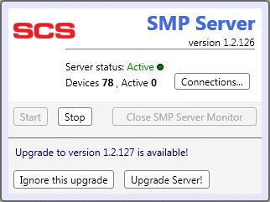
Clicking on the Upgrade Server! button will open a software download page in a browser so that you may download and install the new version of the software. It is also possible to ignore an upgrade to a particular version. In this case, the SCS SMP Server Monitor will never show an upgrade message for the ignored version (but it will show a message when a newer version become available).
TIP
It is also possible to perform a manual upgrade (in rare cases when automatic upgrade fails or was unexpectedly interrupted):
- Use the SMP Server Monitor to Stop the service
- Close the SMP Server Monitor
- Download and run the installation executable from the link mentioned at the beginning of this chapter
- Start the SMP Server Monitor again (from shortcut) and use it to Start the service again

SCS Static Management Program (SMP) Server Maintenance and Troubleshooting
WARNING!
This section contains information about internal implementation details and system file & data organization.
Take special care if manipulating internal SMP files. Any change may result in permanent damage to SMP, and may even render it unusable!
Information in this section is not needed for normal SMP operation and can be skipped by most users.
SMP runs as a Windows service. This effectively makes it a part of the operating system. There is no need to start SMP – when the server computer is booted the service will start automatically. It is also possible to manage SMP with the standard windows Services applet (located under Administrative Tools). The service itself is named SCS SMP Service.
Using the Services applet for SMP management is almost never required, since it is possible to start and stop SMP at any time using the SMP Server Monitor as described before.

Log Files
SMP Server records various events and writes them to readable log files. The size of each log file is limited to 64 KB. If a log file grows beyond this limit, SMP will archive it and open a new “current” log. Current log files are stored in the server folder (normally Program Files\SCS\SMPServerService). The log files archive is created in the subfolder Logs of the server folder. SMP keeps information related to certain classes in separate log files. Common log files are:
- SMP.Server Exception.log – contains information about exceptions (errors)
- SMP.Server Warning.log
- SMP.Server Status.log
- SMP.Server Trace.log
- SMP.Server Debug.log
Archived logs have date/time information appended to the standard log file name.

Log files contain verbose information about SMP operation. That information could often help solve common problems. For example, an Exception log may contain information such as:
2014-04-12 07:58:48 [] System.Net.Sockets.SocketException (0x80004005): No connection could be made because the target machine actively refused it 192.168.1.25:10002
at System.Net.Sockets.Socket.EndConnect(IAsyncResult asyncResult)
at System.Net.Sockets.TcpClient.EndConnect(IAsyncResult asyncResult)
at ModbusServer.ModbusRawDeviceServer.OnConnect(IAsyncResult result)
This entry is showing that the SCS Static Management Program (SMP) cannot communicate with Lantronix hub device connected at IP address marked in red above. The most likely cause is that the device is configured incorrectly.
SMP is a robust system and it handles all exceptions internally. Incorrect network configuration, device disconnection, data loss, or any other condition will not cause SMP to hang. It will log problem information and recover. There is almost never any reason to perform any maintenance for the SMP Server – it is designed to run unattended.
Important
SMP can produce a large number of log files with time. After a year or more of constant operation, the Logs folder can contain thousands of old archive files totaling several gigabytes in size.
It is advisable to clean up old log archives from time to time.

Database
SMP collects huge quantities of data from sensors and stores it in the database. If, for example, a certain sensor measures 10 distinct values, then SMP will have to store 10 numerical values and 10 statuses for this sensor every second. Since values are decimal numbers and statuses can have at least 5 possible values, the size of this data is 84 bytes per second. Considering that SMP is designed to monitor up to thousand sensors in real time, it is easy to calculate how large this stored data is.
To overcome this problem with sheer data size SMP uses specially designed compression algorithms that reduce data size about 80% on average. But, even with all optimizations, data size is still considerable. An average, medium sized SMP system (100-150 sensors) may produce up to 1GB per month. SMP is designed to keep history data indefinitely. It is almost always possible to review sensor readings, alarms or faults for any period of time. This feature requires practically unlimited database size (which is dependent on free disk space).
Even though SQL Server Compact has a data size limitation (4GB) SCS decided to use it as the SMP data store. This eliminates the extra cost of an enterprise-level DBMS, while offering the required performance and reliability. SMP Server uses a special cataloging scheme and heterogeneous queries to make this possible.
The SMP database consists of a set of databases (catalog). Database(s) are stored in the SMP data folder (normally ProgramData\SCSSMP). This data folder will always contain at least these two files:
- SMSDb.sdf – current SMP database
- smscat.xml – SMP database catalog information
SMP will use the current database until it grows to the configured limit. When that happens, SMP will create a new blank database, then copy all system data (devices, hierarchy, and admin data) to it and will continue using this new database as current. The old database is renamed and becomes part of a catalog. When SMP needs to make a query over a long time period it will combine results from several databases seamlessly.
The naming scheme for “old” databases is: SMSDbyyyyMMddhhmm.sdf – date/time of “freeze” is appended to the database name. For example, SMSDb201403150711.sdf was frozen on 2014-03-15 07:11.
It is important to note that “frozen” databases can never change. They hold old data and SMP only reads them. This simplifies data backup since it is enough to back up “old” databases only once. Only database SMSDb.sdf is changing constantly.
Database catalog smscat.xml is standard XML file containing all relevant information for SMP database engine. Here is an example:
<?xml version="1.0" encoding="utf-8"?>
<DataCatalog xmlns:i="http://www.w3.org/2001/XMLSchema-instance" xmlns="http://schemas.datacontract.org/2004/07/SMS.Database.EF">
<CheckSpan>PT0S</CheckSpan>
<CheckTime>PT2H</CheckTime>
<DatabaseSplitSize>1024</DatabaseSplitSize>
<Entries>
<DataCatalogEntry>
<Database>SMSDb</Database>
<UtcBegin>1404088500</UtcBegin>
<UtcEnd i:nil="true" />
</DataCatalogEntry>
<DataCatalogEntry>
<Database>SMSDb20140630023810</Database>
<UtcBegin>1402632000</UtcBegin>
<UtcEnd>1404088690</UtcEnd>
</DataCatalogEntry>
<DataCatalogEntry>
<Database>SMSDb20140613060304</Database>
<UtcBegin>1401410100</UtcBegin>
<UtcEnd>1402632183</UtcEnd>
</DataCatalogEntry>
</Entries>
</DataCatalog>
This shows a database consisting of 3 files (the current, and two old frozen databases) described as DataCatalogEntry. This node contains:
- Database – database file name (without .sdf extension)
- UtcBegin, UtcEnd – defining time interval of history data stored in it. Time is in UTC – number of seconds since 1970-01-01.
The database catalog also contains some configuration parameters:
- DatabaseSplitSize – maximum size (in megabytes) of a database. When data size grows above this limit then SMP initiates the archiving procedure described above.
- ChekSpan, CheckTime – defines the time of day when the SCS Static Management Program (SMP) server performs this size check (and potential archiving). Since this procedure may take more than a couple of seconds it is, by default, scheduled for 2 AM every night.
WARNING!
Changing smscat.xml in any way, renaming or deleting .sdf files is almost certain to corrupt SMP beyond repair. It will always lead to weird and unexpected behavior.
If there is any need for manually changing this data please contact SCS and make backup of entire SCSSMP folder first.
One reason for doing this may be a desire to discard ancient history data by deleting related databases and catalog entries. There is normally no need to do such thing because SMP doesn’t open a database unless it needs it. Therefore old databases do not take processor resources or affect SMP performance in any way (except taking up disk space).
It is also possible to “make a fresh start” – remove everything and start from a blank system. To make a fresh start one should:
- close SMP Server service
- delete smscat.xml and all .sdf files from SCSSMP folder
- start SMP Server again
Notice that in case of clean start all system data gets lost too (devices, configuration, hierarchy, users, …)

Insight
SMP Database is a standard SQL database. It is possible to use any standard tool for management using standard SQL statements.
It is not advisable to change data because it can ruin database consistency. History data is stored in compressed format that is unreadable without SMP.
For inspecting SMP databases there is an excellent freeware database manager available:
Database.NET
This manager opens almost all SQL databases.

SCS Static Management Program (SMP) Client Applications Installation
Installation of the Client Applications is quite similar to the server installation. Setup program is available from:
this link
Setup can install one or more of following Client Applications:
- SCS SMP Client
- SCS SMP Admin
- SCS SMP Plant Editor
The setup program will also check for Microsoft .NET Framework 4 and install it if necessary.

Program and Data Location
Standard installation creates the folder SCS under Program Files and a subfolder SMPClientApps. It is possible to change program installation location during setup, but this is seldom necessary. Standard program location is (on typical Windows computer):
- C:\Program Files\SCS\SMPClientApps
This folder contains all selected client applications.
Client applications store user preferences in a folder SCSSMP located under Common User Data folder. Location of this folder depends on OS and installation option (install for all users or single user) but in default case under typical Windows it is:
- C:\Users\{username}\AppData\Roaming\SCSSMP

Software Upgrade
Whenever a new major software version becomes available SCS will advertise it and it will be possible to upgrade the SCS Static Management Program (SMP) client applications to the latest version. SCS SMP uses an automated upgrade notification procedure. Whenever a new version is available both SCS SMP Client and SCS SMP Admin will show (on splash screen during startup):
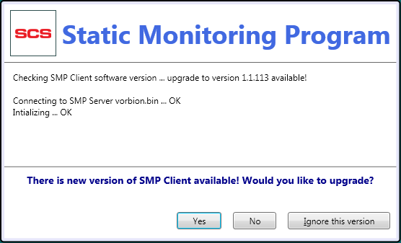

The upgrade procedure is identical to server upgrade – clicking on Yes will open installation download page in browser and from then on it is a matter of downloading and running the installation executable.
TIP
It is also possible to perform a manual upgrade (in rare cases when automatic upgrade fails or was unexpectedly interrupted):
- Download and run the installation executable from the link mentioned at the beginning of this chapter

